Curriculum Vitae

Noor Mohammed Mohammed Rifkan
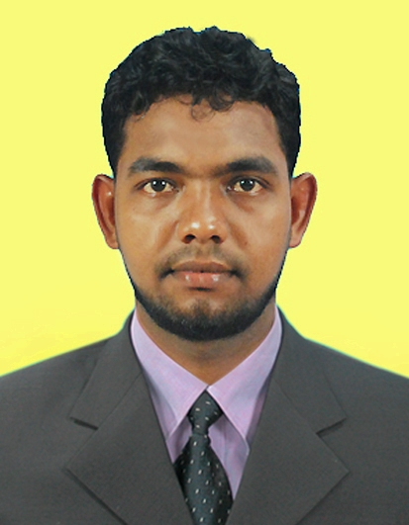

13, APC Road,

Irakkamam-04,

Sri Lanka.

Mobile: +94774898439, 0757290774

Mail: rifkanhami@gmail.com

Career Aim

To pursue a highly rewarding career, seeking for a job in challenging and healthy work environment where I can utilize my skills and knowledge efficiently for organizational growth.

Professional Profile

Human Resource Assistant and Officer Level roll with over 4 years of experience. Expert at administrative work as human resource officer. Possess excellent administrative service, Public relation and communication skills implemented as new Human resource strategies. Keeping time management and cutting wasting expenses.
Employer / Organization : Human Resource Assistant
Al-Hamiya Arabic College, Kalmunai,
Duration : 03 years (2008.01.08 to.2012.01.06)

Nature of job carried out – Job Detail:
Following jobs are carried out from best of my Knowledge:
- At Al-Hamiya Arabic College Kalmunai for a period of 03 years from 2008.01.08 to 2012.01.06.
- Serves as Human Resource assistant for student recruitments.
- Manage students’ attendants
- Draft letters to related institution for students
- Serves as filing in charge such students and staff personal files
- Serves as information officer (Deal with students and parents for sharing information)
- Solves problem among students with the advice of the Director
- Prepare vouchers, list of students and staff details
- overall communication for administrative behaves

Employer / Organization : Human Resource Officer
Al-Hamiya Arabic College Kalmunai
Duration : Over 01 year (01.10.2014-24.07.2015)

Nature of job carried out – Job Detail:
Following jobs are carried out from best of my Knowledge:
- At Al-Hamiya Arabic College Kalmunai. for a period of over 01 year from 01.10.2014 24.07.2015.
- Supervise and coordinate activities of staff
- Interview Students applicants
- Conduct orientation programmes for College Students
- Administer salaries and work out leave entitlements
- Be involved in student training and development, the preparation of assessments and Course trainings
- Prepare annual estimates of expenditure, maintain budgetary and inventory controls and make recommendations to management
- Maintain management information systems (manual or computerized)
- Provide secretarial or executive services for committees.
- Performance appraisal
- Health and Safety activities.

Academic & Professional Qualification

- Successfully completed the higher studies in Islamic theological (Law) and academic subjects for eight years and successfully passed the examination in 2011
- Undergraduate Education: Awaiting final results for the award of the Degree of Bachelor of Arts-2013 (extranal) in University of Peradeniya, Sri Lanka.

- Higher National Diploma in Management (Specialization in HRM) at Hardy Advanced Technological Institute (SLIAT).

- Awaiting final results.

Educational Qualification

- Secondary level:
Best performance in General Certificate of Education (Ordinary Level) Examination: G.C.E (O/L) – 2008/ December

- Arabic A History C
- Arabic Literature A English C
- Islam A Tamil C
- Health Science B Mathematics S

Best performance in General Certificate of Education (Advanced Level) Examination: G.C.E (A/L) – 2010 August: Index No: 6428703.

- Arabic B
- Islamic Civilization C
- Political Science S
- General Test 50

  - Successfully completed Al-Alim & Daham School Final Certificate Examination Conducted by examination department,
  - Successfully completed Basic/Spoken English (The English Language Institute-Kandy).
  - Successfully completed Diploma in Computer (Sano computer System),

Skills and Achievement

- Very Good IT Knowledge in MS-Office, Internet & Email.
- Leadership Training program at Batticolo – University College,
- Good communication skills and socialism resource planning portfolio gained from during my course giving class presentations.
- Sound knowledge in HRM Reports assignments supervised and handled internal organizations.
- Participation on “common cancers & health hazards of tobacco smokeless tobacco & arecanut use” Conducted by Ministry of Health- Sri lanka,
- I have Driving Licence.

Language Skills

 | Oral | Writing | Reading | Typing
Tamil | Fluent | Fluent | Fluent | Fluent
Arabic | Good | Fluent | Fluent | Fluent
English | Good | Fluent | Fluent | Fluent
Sinhala | Good | Good | Good | I Try

My Identity
- Good Team Player
- Pro Active
- Self-Motivated

Extra - Curricular Activities

- Secretary of Safa Welfare Community Center. Irakkamam-04,

- Member of All Ceylon Jammiyathul Ulama Reg.No.3469,

- I am a Teacher and Administrative Officer at Al-Hilal Ahadiya School.

Personal Details

Full Name : N.M.M.Rifkan.
Address : No- 13, APC ROAD, IRAKKAMAM-04.
Tele. No : +94774898439, 0757290774
E-mail : rifkanhami@gmail.com
NIC No : 900093527 V

Passport No : N5580307
Date of Birth : 1990-01-09

Sex : Male

Civil Status : Single
Nationality : Sri Lankan

Non-Related Referees

I truly and sincerely attest that the above information furnished by me is true and accurate to the best of my knowledge.

Ariff Samsudeen,
(Attorney–at-law),
Member of Eastern provincial Council,
Kalmunai,
ariff_samsudeen@hotmail.com
Tel: 077-2515 790

2015-10-22
Hamila Sammhoon BBA(spe.in.HRM),
MBA(SL),
Lecturer,Department of HRM,
Hardy campus.
sithyhamila@gmail.com
Tel: 077-1040730

Rifkan
--------------------- -----------------------------
Date Signature
(NMM.Rifkan)

